For GitOps theory: https://opengitops.dev/
Visit getting started with ArgoCD page: https://argo-cd.readthedocs.io/en/stable/getting_started/
NOTE:
- ArgoCD only support git based solutions
Create your kind cluster:
- kind create cluster --name=faraz-argocd-demo
- kind get clusters
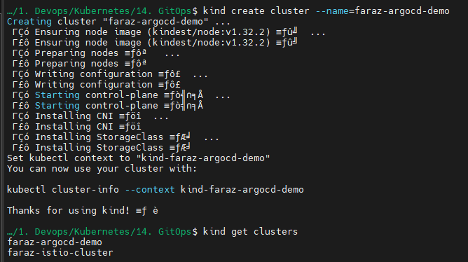
Install ArgoCD:
- kubectl create namespace argocd
- kubectl apply -n argocd -f https://raw.githubusercontent.com/argoproj/argo-cd/stable/manifests/install.yaml
Install ArgoCD using HELM: https://github.com/argoproj/argo-helm
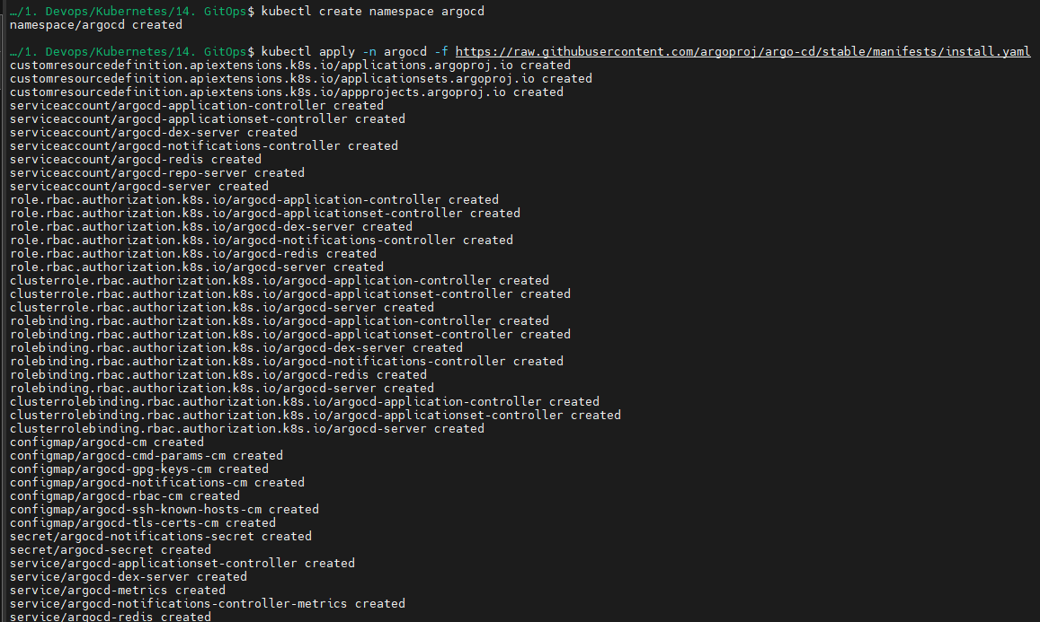

Wait for pods to come up:
- kubectl get pods -n argocd
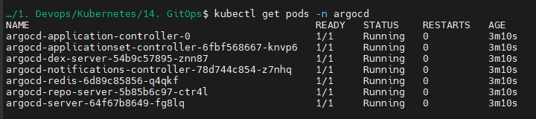
Now we will try to access Argocd from our web browser:
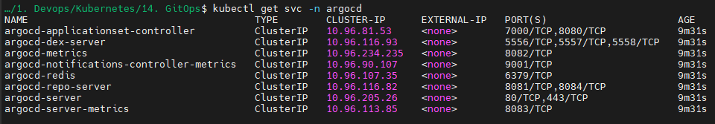
- kubectl port-forward svc/argocd-server -n argocd 8080:80
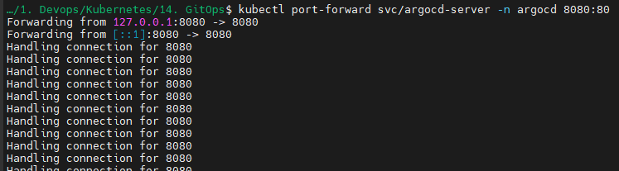
You will now be able to access ArgoCD UI:
Open: https://localhost:8080/
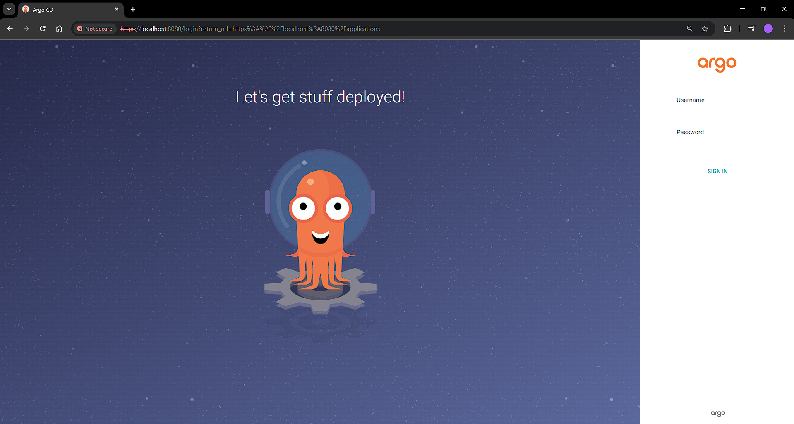
Since we have not integrated SSO/LDAP via DEX, we are unable to see Login via Google/Facebook/GitHub, etc.
To get the username and password:
- kubectl get secret -n argocd
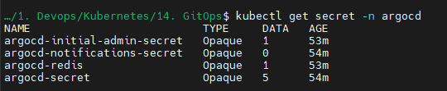
- kubectl edit secret argocd-initial-admin-secret -n argocd
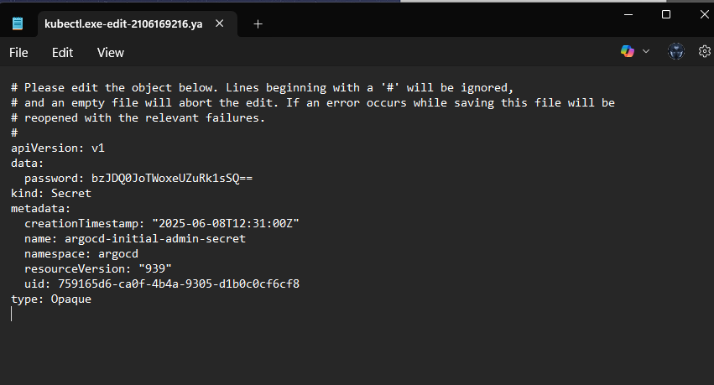

Type in your credentials:
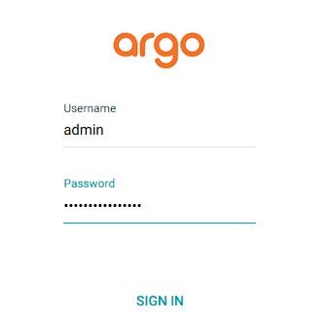
You will be logged in to your application:
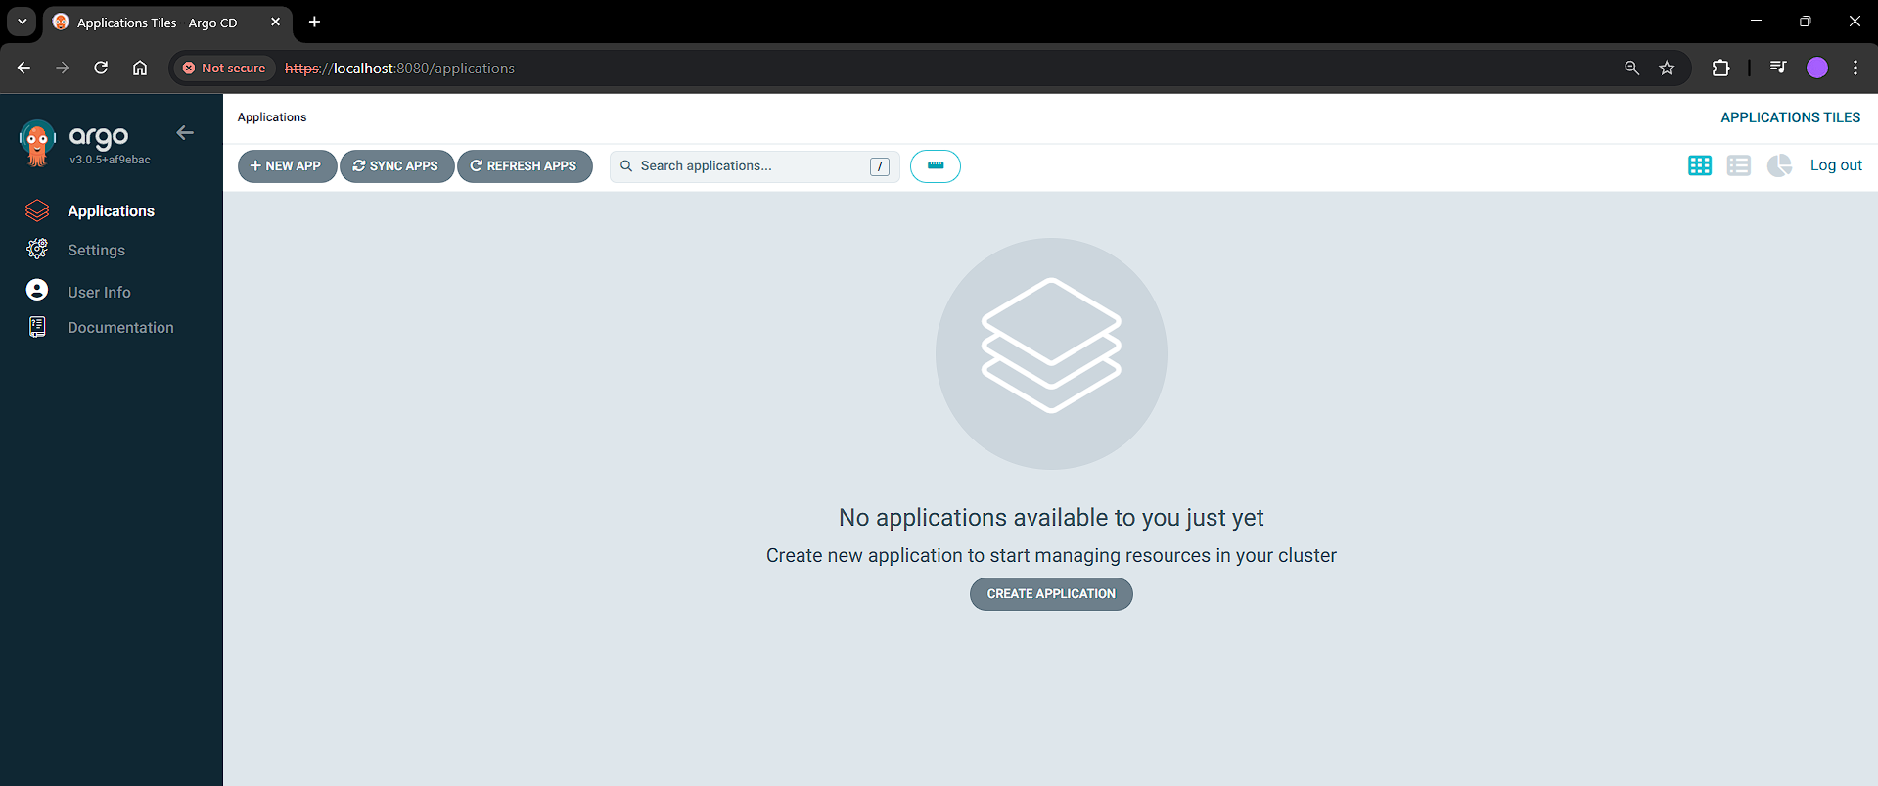
You can use example apps: https://github.com/argoproj/argocd-example-apps

Let’s create our first application:
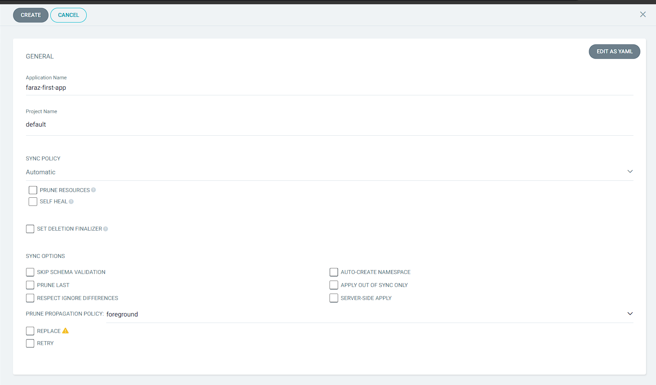
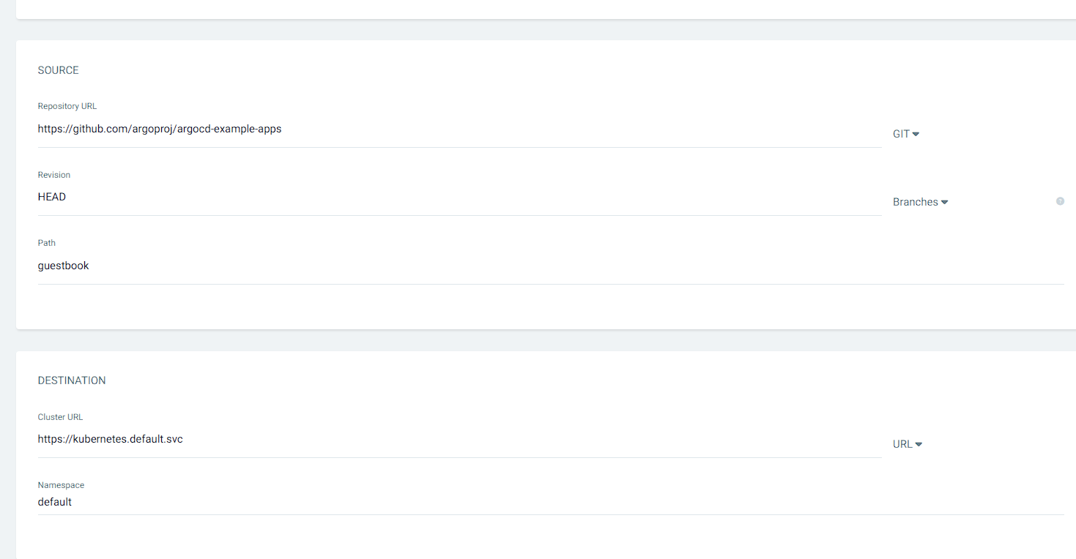
Now click on create

You may notice that your application is deployed in default namespace which we selected:
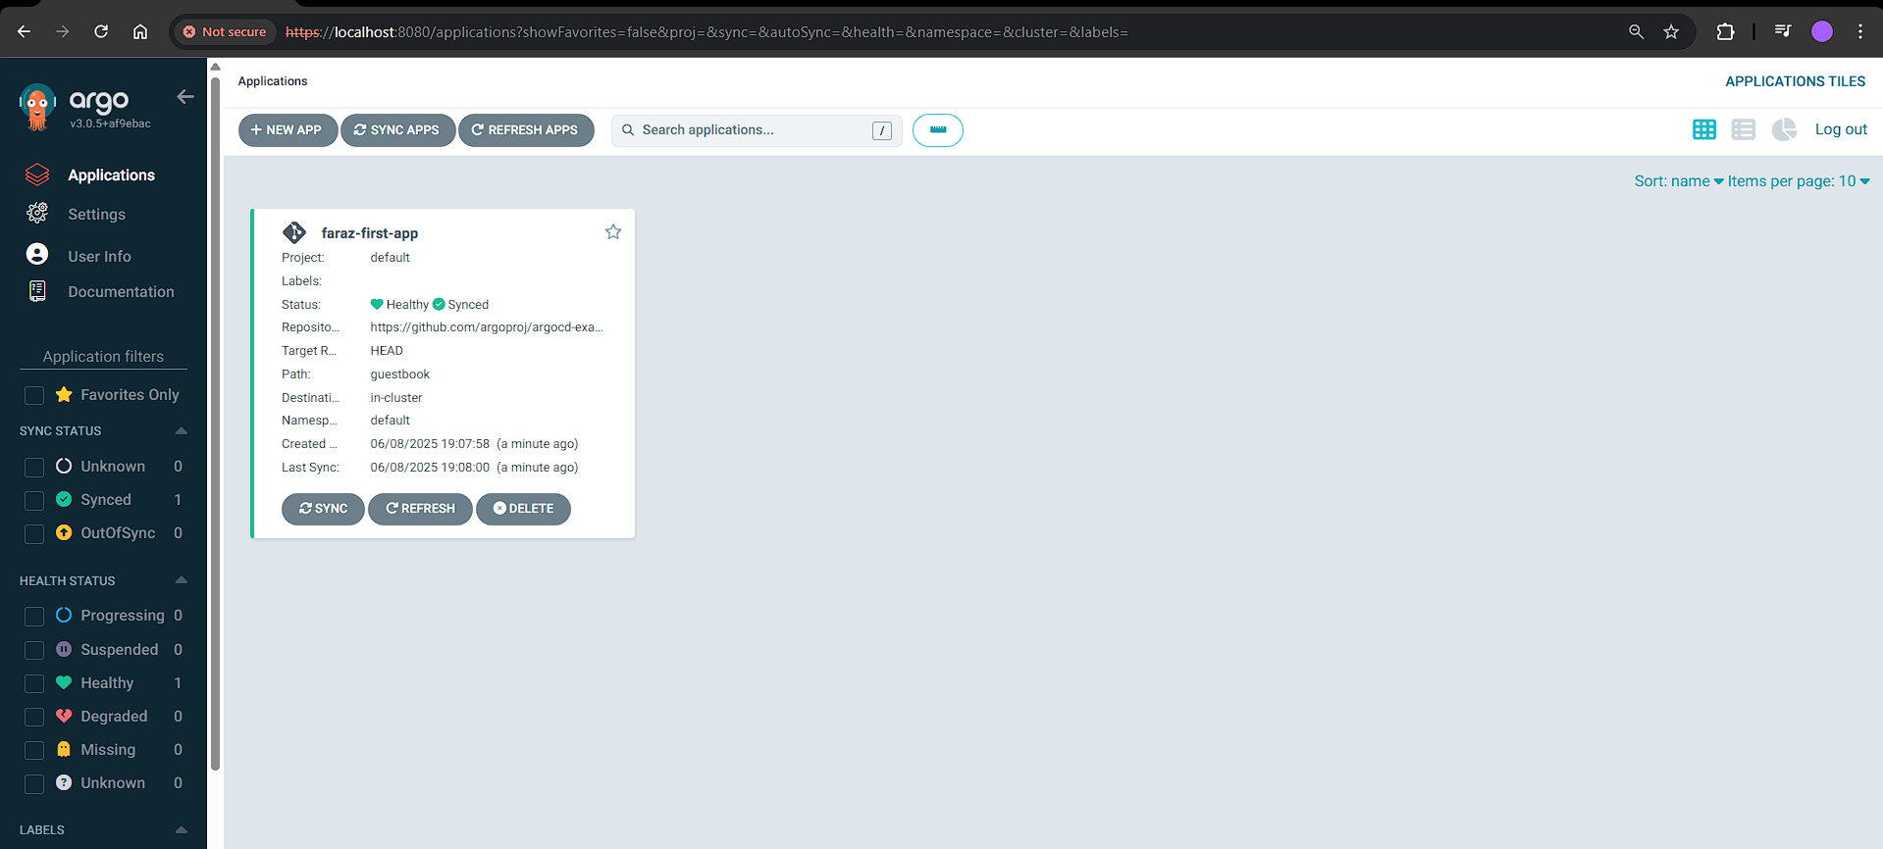
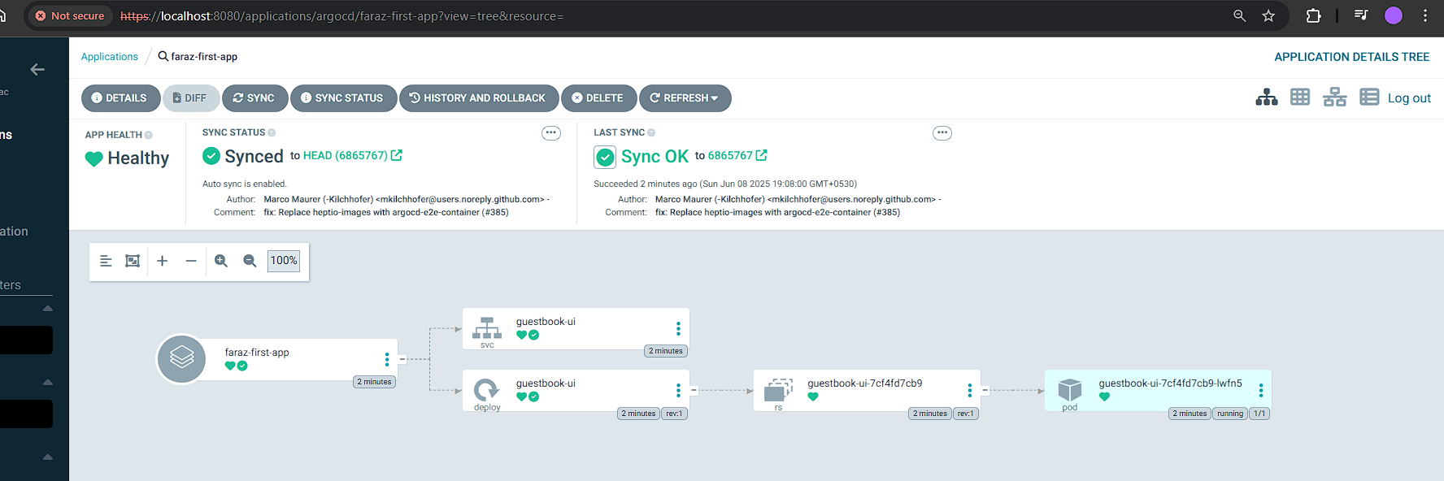
- kubectl get all -n default
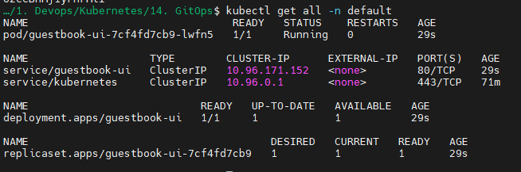

Now let’s try deploying application from our repository:
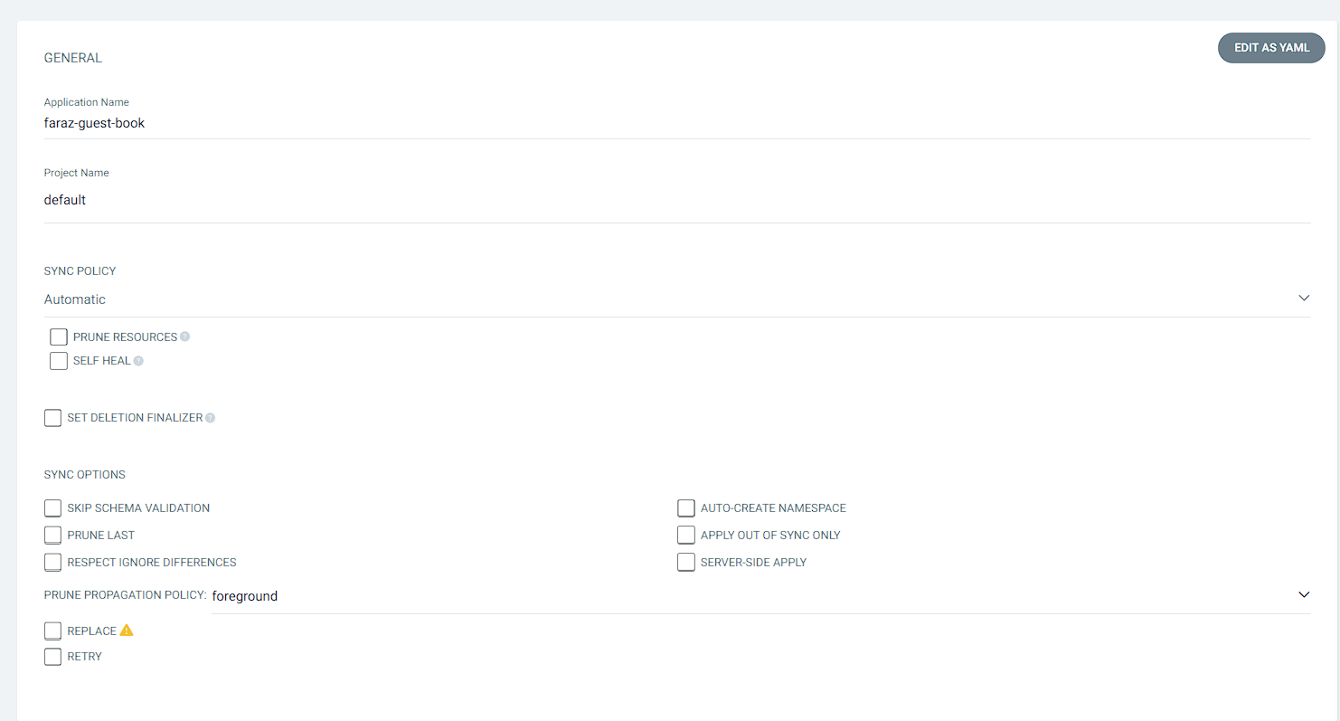
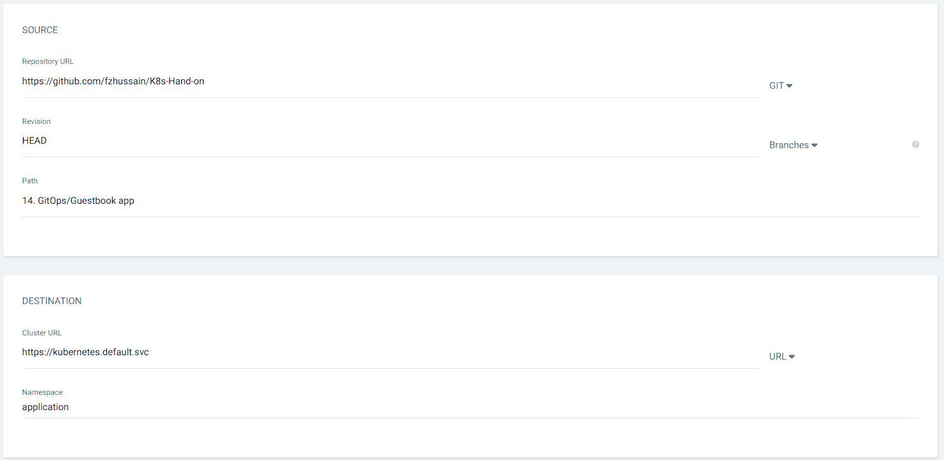

Verify the resource creation:
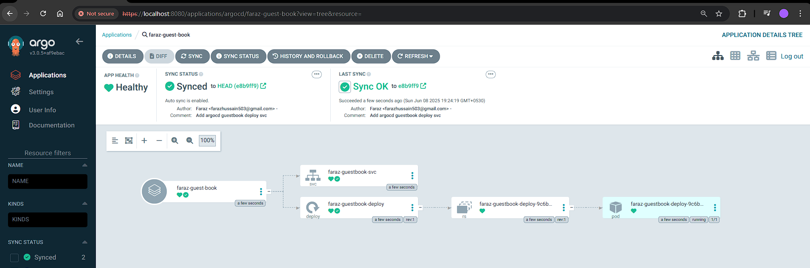
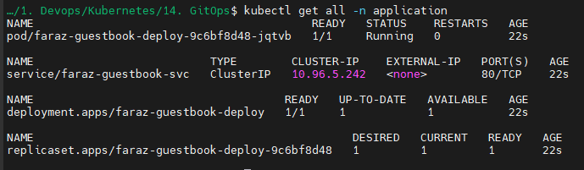
Now let’s try increasing the replicas to 3:
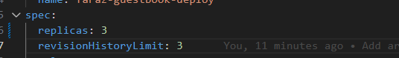
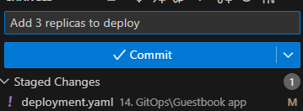
And now push it

Now refresh it:
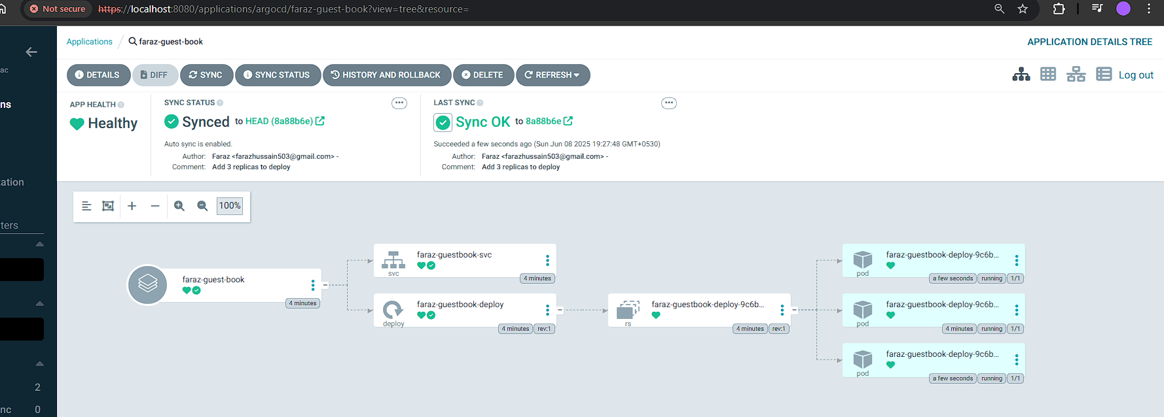
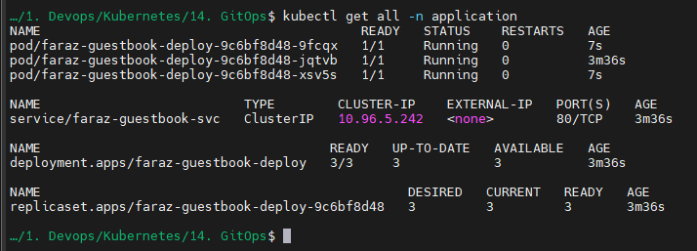
You may confirm that 3 replicas are now created on pushing to the GIT repo.

Now let’s install ArgoCD CLI in windows:
You can follow the documentation to install: https://argo-cd.readthedocs.io/en/stable/cli_installation/#windows
To create an app: https://argo-cd.readthedocs.io/en/latest/user-guide/commands/argocd_app_create/
Login to argocd via CLI:
- argocd login localhost:8080 --username admin --password o2CCBhMj1yFnFMl
Create an application:
- argocd app create faraz-guestbook-via-cli --repo https://github.com/argoproj/argocd-example-apps.git --path guestbook --dest-namespace default --dest-server https://kubernetes.default.svc --directory-recurse
Verify your app creation:
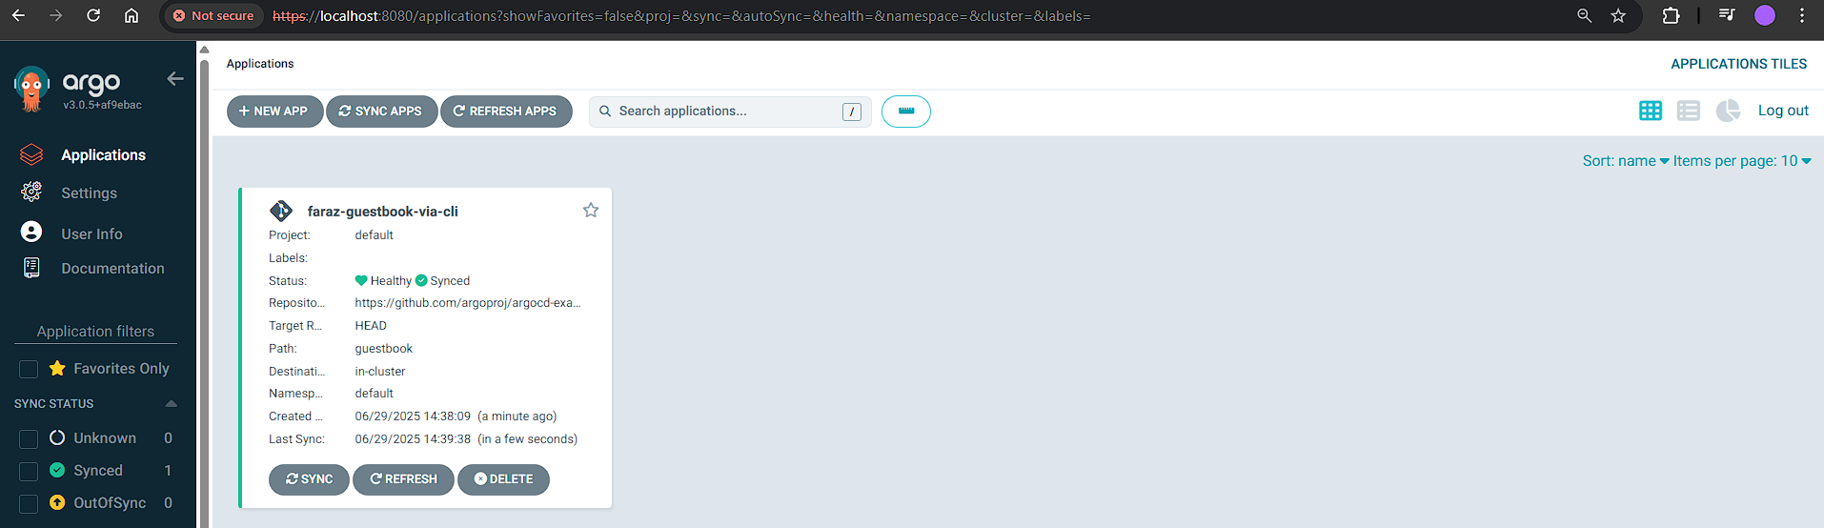
- The --dest-namespace default flag tells Argo CD where to deploy the guestbook app’s resources (like Deployments, Services, etc.) — in this case, to the default namespace of your Kubernetes cluster.
- However, Argo CD itself stores and manages the Application custom resources in the argocd namespace by default. That’s why:
kubectl get application -n argocd
shows the app, but querying the default namespace doesn’t — because the Application object wasn’t created there.
- --dest-namespace: where the app deploys its resources.
- -n argocd: where Argo CD's Application CRD lives.

